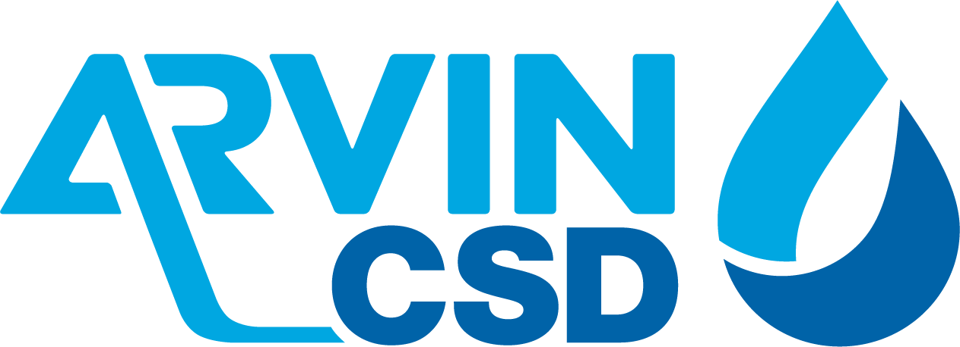

309 Campus Drive, Arvin, CA 93203
REGULAR MEETING AGENDA OF THE REGULAR MEETING OF
ARVIN COMMUNITY SERVICES DISTRICT BOARD OF DIRECTORS
President’s Day - Office will be Closed on Monday, February 17, 2025
Tuesday, February 18, 2025, 6:00 P.M.
**************************************************************
Call Meeting to Order Board President Reyna

Roll Call: Aurelio Reyna Board President
Adam Ojeda Board Vice President
Rafael Gallardo Board Director
Maria Moreno Pantoja Board Director
Manuel Pantoja Board Director
Staff
Raul Barraza, Jr. General Manager
Alan Peake District Counsel
Dee Jaspar District Engineer
************************************************************************************
This meeting is held in accordance with the Brown Act. Individuals may address the Board on any matter listed on this agenda, excluding closed session. Members of the public desiring to address the Board must request recognition from the Board President. Presentation by members of the public is limited to two minutes each per agenda item.

Flag Salute: Board and audience salute flag.

- Public Comment
This portion of the meeting is set aside for members of the public to address any matter not on this agenda and over which the Board has jurisdiction. Comments are limited to 2 minutes for each person and 15 minutes on each subject.

- Consent Calendar
The Consent Calendar consists of items that in the staff’s opinion are routine and non-controversial. These items are approved in one motion unless a Board Member or member of the public removes a particular item.
  - Approval of Regular Meeting Minutes of February 3, 2025
  - Accounts Payable for February 3, 2025 – February 14, 2025
Motion: ______________________________________________________________
Director ______________________, seconded Director_______________________
Roll Call: BD Gallardo __ BD Moreno Pantoja __ BD Pantoja __ VP Ojeda __ BP Reyna __

- Board to discuss and take action re: Appeal to the City of Arvin Planning Commission Action related to Conditional Use Permit and Site Development Permit for Arvin Community Services District Solar Array
Motion: ________________________________________________________________________
Director ________________________, seconded Director___________________________
Roll Call: BD Gallardo __ BD Moreno Pantoja __ BD Pantoja __ VP Ojeda __ BP Reyna __

- Board to discuss and take action re: Kern Subbasin Probationary Hearing on February 20, 2025
Motion: ________________________________________________________________________
Director ________________________, seconded Director___________________________
Roll Call: BD Gallardo __ BD Moreno Pantoja __ BD Pantoja __ VP Ojeda __ BP Reyna __

- Staff Comments:
  - General Manager’s Report
  - Legal Counsel
  - District Engineer

- Board Member Comments:
This portion of the meeting is set aside to provide the Board with an opportunity to bring any new matters to the attention of the District. However, while no action can be taken on any matter discussed during this portion of the meeting, a Board Member may request that a subject be placed on an upcoming agenda. This portion of the meeting also allows the Board to get a brief update on any matter addressed at a previous meeting.
Director Gallardo | Director Pantoja Moreno | Director Pantoja | VP Ojeda | President Reyna

Motion to go into closed session made by _____________, Seconded By ____________
Roll Call: BD Gallardo __ BD Moreno Pantoja __ BD Pantoja __ VP Ojeda __ BP Reyna __
- Closed Session
  - Meeting with Legal Counsel regarding Potential Initiation of Litigation Government Code 54956.9 (d) (4) one case.
Motion to go back into open session made by ______________, Seconded By _____________
Roll Call: BD Gallardo __ BD Moreno Pantoja __ BD Pantoja __ VP Ojeda __ BP Reyna __
Closed Session Report: _______________________________________________________

- Adjournment:
Director ________________________, seconded Director___________________________
Roll Call: BD Gallardo __ BD Moreno Pantoja __ BD Pantoja __ VP Ojeda __ BP Reyna __

I hereby certify under perjury under the laws of the State of California that the foregoing agenda was posted on the Arvin Community Services office window and website not less than 72 hours prior to the meeting dated February 18, 2025.
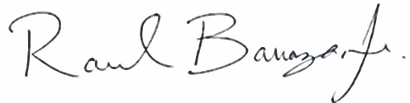

Raul Barraza, Jr.
Board Secretary/General Manager

AMERICANS with DISABILITIES ACT: In compliance with the ADA, if you need special assistance to participate in a District meeting or other services offered by the District, please contact the District Board Secretary's office (661) 854-2127. Notification of at least 24 hours prior to the meeting or time when services are needed will assist the District staff in assuring those reasonable arrangements can be made to provide accessibility to the meeting or services.

